|  |
| --- |
| EXERCISES |
|

**TASK # 01:**

Get empno,ename,sal,deptno from emp table .

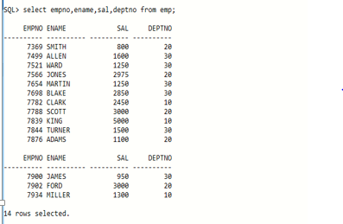

**TASK # 02**

Count total number of employees**.**

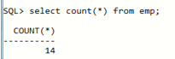

**TASK # 03**

Get the highest and the lowest salary from emp table.

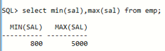

**TASK # 04**

Calculate net salaries of employee (by adding salary and comm).

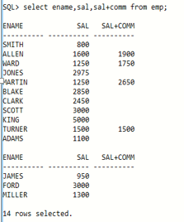

**TASK # 05**

Display all the deptno that employees belong to, but don’t allow repetition

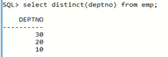

**TASK # 06**

Display data of all employees who work as Salesman.

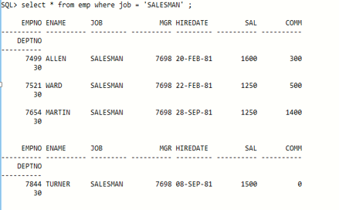

**TASK # 07**

Display names of employees who work in deptno 20.

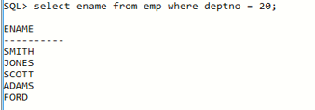

**TASK # 08**

Calculate one year salary of every employee from emp table.

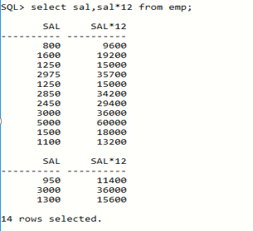

**TASK # 09**

Display the total count of departments from dept table

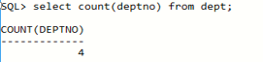

**TASK # 10**

Display the employee name whose salary is more than 2000 but less than 3500.

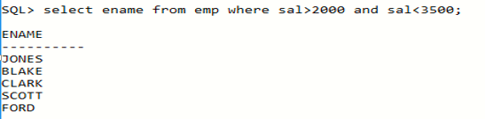

**TASK # 11**

Display all employee names and their manager number from emp table.

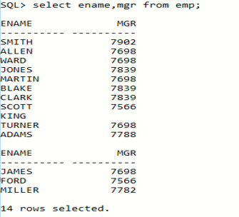

**TASK # 12**

Show the average salary of all employees.

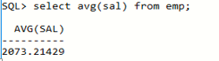

**TASK # 13**

Show the total salary of all employees.

